# **Factor Plot**

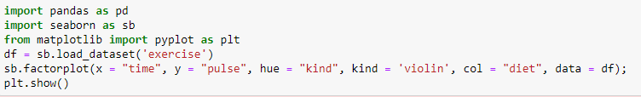

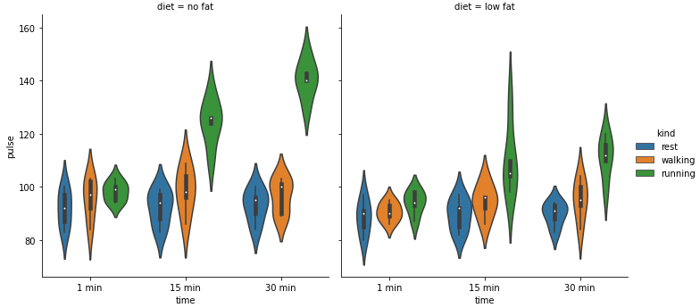

Code Details :

* x = “time”: This specifies the categorical variable to plot on the x-axis. In this case, it is the time of exercise.
* y = “pulse”: This specifies the quantitative variable to plot on the y-axis. In this case, it is the pulse rate of the participants.
* hue = “kind”: This specifies another categorical variable to group the data by color. In this case, it is the kind of exercise (Rest, Walking, Running).
* kind = ‘violin’: This specifies the kind of plot to draw. In this case, it is a violin plot.
* col = “diet”: This specifies another categorical variable to split the data into multiple columns. In this case, it is the diet of the participants (No fat, Low fat).
* data = df: This specifies the data frame that contains the data.

observations from the output plot are:

* The plot shows how the heart rate changes depending on the time of day, the type of exercise and the diet.
* The shape of the plot shows how spread out or clustered the heart rates are for each group. A wider shape means more variation and a narrower shape means less variation.
* The color of the plot shows the type of exercise: blue for resting, green for running and orange for walking. The column of the plot shows the diet: no fat or low fat.
* The plot shows that running makes the heart rate go up a lot, especially in the evening. Walking makes the heart rate go up a little bit, but not as much as running. Resting does not change the heart rate much at all.
* The plot also shows that some people have very high or very low heart rates compared to others. This could be because of their fitness level, health condition or other factors.
* The white dot and the black lines inside the plot show the middle and the range of the heart rates for each group. The white dot is the average heart rate and the black lines are the boundaries of where most of the heart rates are. For example, most people who run in the evening have a heart rate between 140 and 180 beats per minute, with an average of 160 beats per minute.
* The plot shows that the morning and the afternoon have similar heart rate distributions for each type of exercise, while the evening has higher and more variable heart rates.
* The plot shows that the diet does not have a clear effect on the heart rate distribution, as the no fat and low fat groups have similar shapes and ranges for each type of exercise and time of day.
* The plot shows that the resting group has the lowest and most consistent heart rate across all categories, while the running group has the highest and most variable heart rate across all categories. The walking group is in between the resting and the running groups in terms of heart rate level and variation.